SELECT p.productCode, p.productName

FROM products as p

WHERE p.productDescription LIKE '%Chrome Trim%'

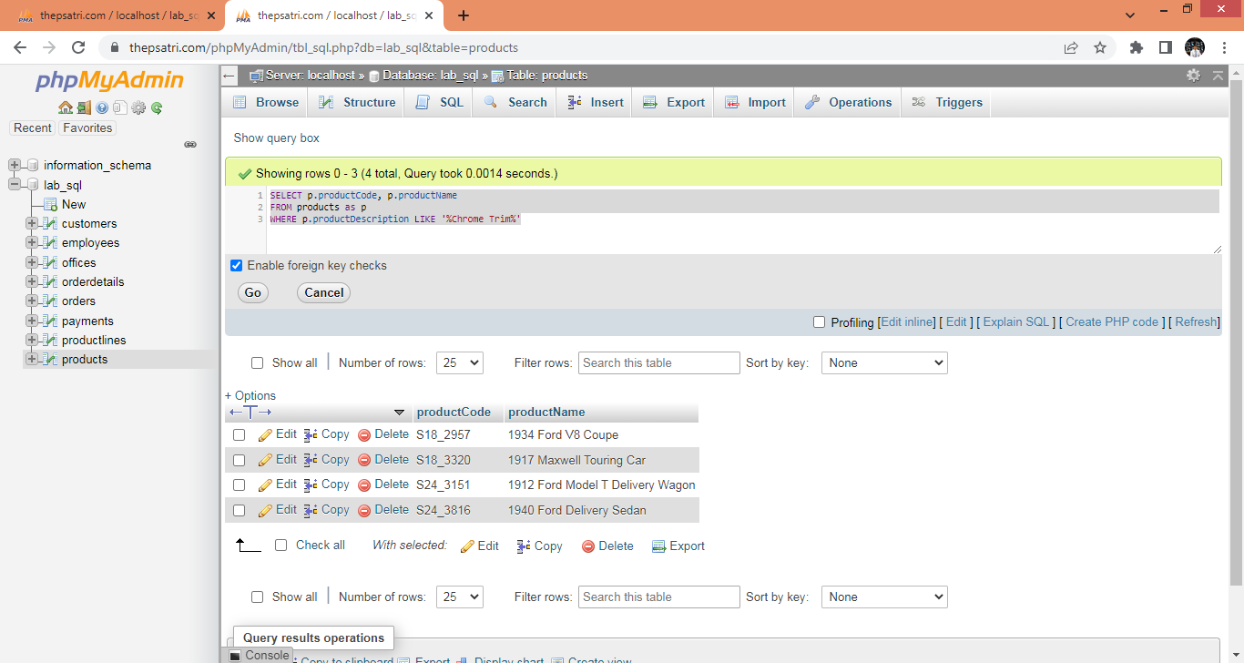

SELECT DISTINCT od.orderNumber

FROM orderdetails as od

WHERE od.productCode IN ('S18_2957','S18_3320','S24_3151','S24_3816')

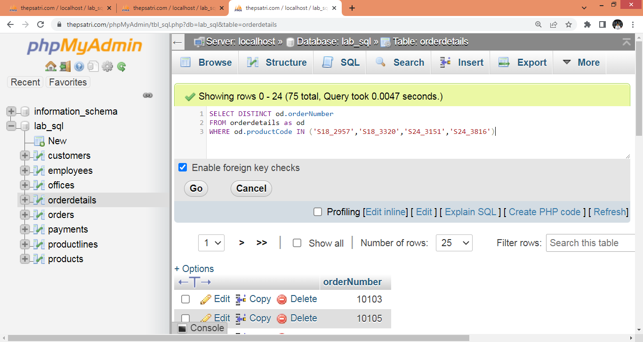

SELECT DISTINCT od.orderNumber

FROM products as p

LEFT JOIN orderdetails as od

ON p.productCode = od.productCode

WHERE p.productDescription LIKE '%Chrome Trim%'

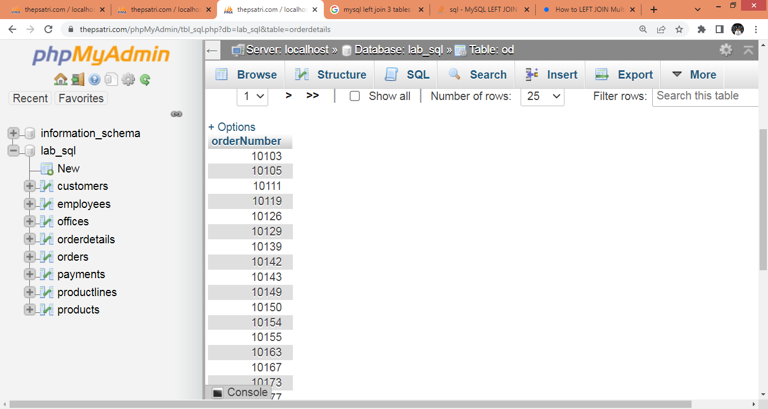

SELECT o.orderNumber,o.customerNumber

FROM orders as o

WHERE o.orderNumber IN (10103,10105,10111)

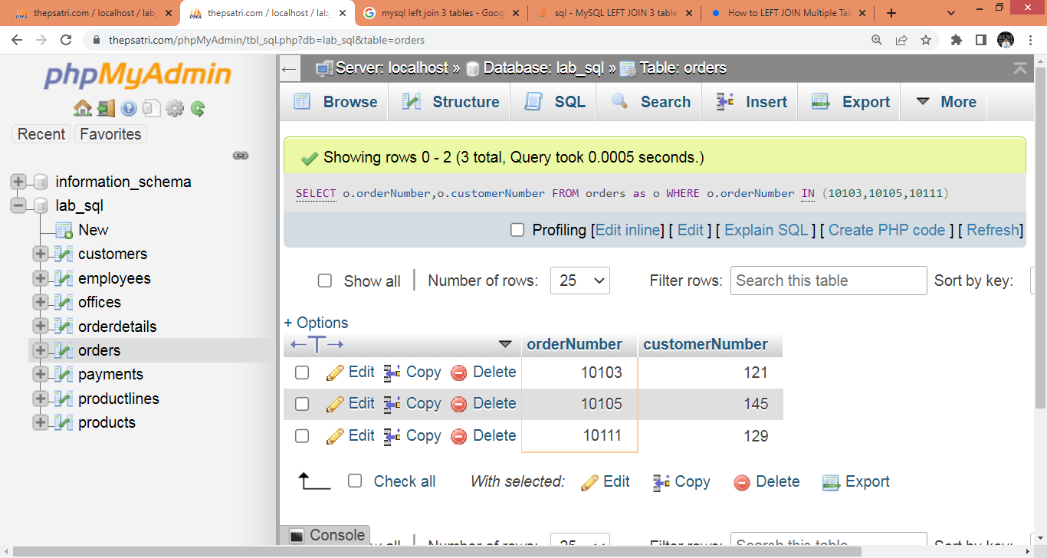

SELECT DISTINCT od.orderNumber, o.customerNumber

FROM products as p

LEFT JOIN orderdetails as od

ON p.productCode = od.productCode

LEFT JOIN orders as o

ON od.orderNumber = o.orderNumber

WHERE p.productDescription LIKE '%Chrome Trim%'

---------------------------------------------------------------------------------------------------------------------------------------------

SELECT DISTINCT od.orderNumber, p.productCode, o.customerNumber, c.customerName

FROM products as p

LEFT JOIN orderdetails as od

ON p.productCode = od.productCode

LEFT JOIN orders as o

ON od.orderNumber = o.orderNumber

LEFT JOIN customers as c

ON o.customerNumber = c.customerNumber

WHERE p.productDescription LIKE '%Chrome Trim%'